Ten Great Tips For 2011
1. Stay out of trouble.
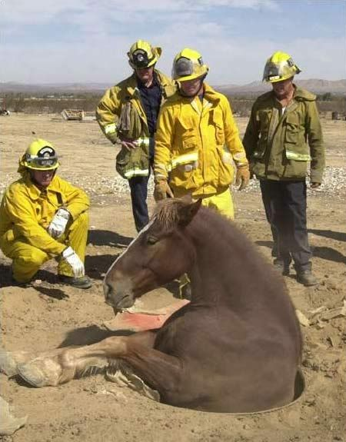
2. Aim for greater heights.

3. Stay focused on your job.

4. Exercise to maintain good health.

5. Practice team work.

6. Rely on your trusted partner to watch your back. Take your time trusting others.

7. Save for rainy days.

8. Rest and relax .

9. Always take time to smile.

AND
10.. Realize that nothing is impossible.

And remember this:
"You don't stop laughing because you grow old,
You grow old because you stop laughing!!!"

